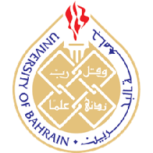

University of Bahrain

Collage of Information Technology

Department of CE

**ITCE320: Network Programming, S1 2022-2023**

**Multithreaded Flights arrival Client/Server Information System**

**Course instructor:** Dr. Mohammed Almeer

Group: 12

Name: Mohammed Albastawy, ID: 20180992

Name: Ali Alshameri, ID: 20193831

**Introduction**

In this project, we will try to implement a client/server module for enquiring information about flights at a certain airport by Visual Studio Code, python, and Json. We will make the server connect with multiple clients at the same time. Each client has his data from the specific website via API. We will use GetHub and Get bush to share files and Microsoft Teams to communicate and share ideas.

**Objectives:**

* We will use GetHub to share file and modify them together with my partner.
* We will import socket library to create a client/server model that that connects to specified IP addresses.
* We will import threading to make possible of server to handle multiple clients at the same time and using send and receive functions.
* We will import requests, retrieve, and read data using http request that will helps to access to the data.
* We will use Json and api to to convert and load data in server file.